Luc and Friends Scum meetings:

Sprint 1
Scrum meeting 1: 7 April 12:20-12:26
Erin and Luc work on home pages and dashboards.
Yami is going to finish apis for the database tables
Need to start working on proper backend stuff, google auth, rooting to other pages.

For now: main goal- resident home page
Adding wards- Fakir
Getting user locations - Chris
Google 0 auth login - Luc (user registration)
Notifications/pulling reports- Erin
Contact information editing (user icon management) – Yami
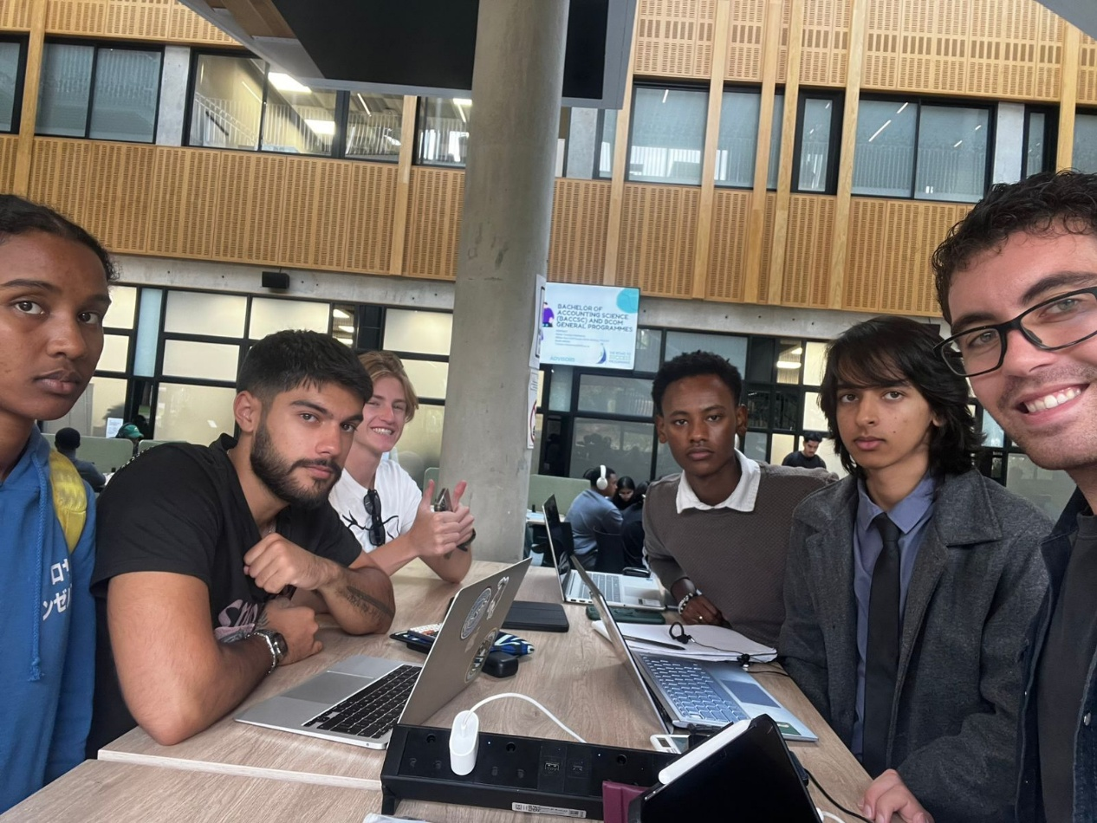

Scrum Meeting 2: 8 April 08:45- 08:52

Fakir has done all the models and index pages for logic associations.
Yami is working on endpoints, specifically workers.
Erin is still on municipal workers page.
Chris is going to help Yami.
Luc will carry on with the login/google auth.

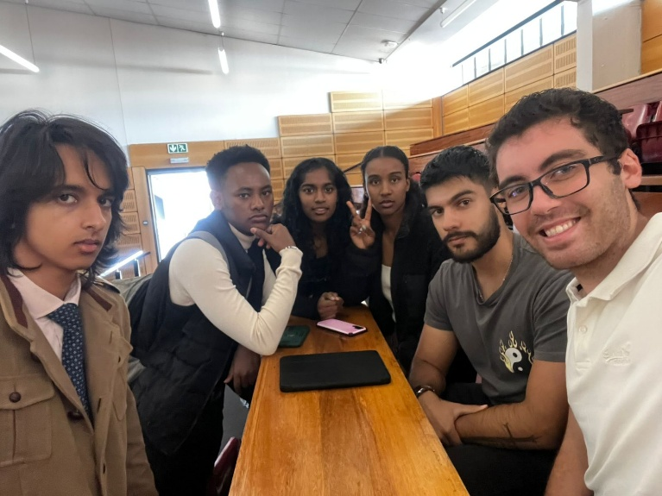

Scrum Meeting 3: 10 April 19:47-19:54

Luc is done with the login auth for residents, will work on workers tomorrow.
Chris will do admin page.
Yami route files are pretty much done, will be done tomorrow.
Fakir will carry on with wards.
Yami explained some of the database models and how they connect to Fakirs work. Luc talked about the Google auth and how the password part in the login is useless if we’re not using passwords but rather Google Auth to login/sign up.

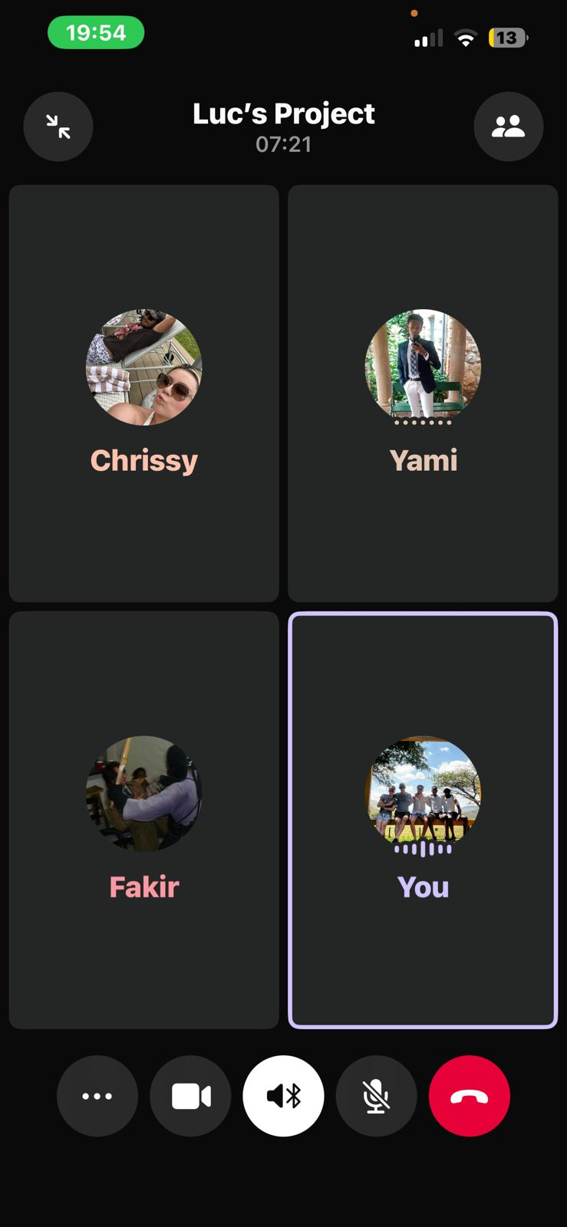

Scrum Meeting 4: 11 April 09:00-09:03

Luc will finish municipal workers logon for Google auth.
Yami will finish up endpoints
Erin will get workers page done and start with notifications functionality.
Chris will finish admin page so we can add an admin user and have it redirect there from the login page.
Fakir will build all Jest cases for testing of his and Yami’s backend code.

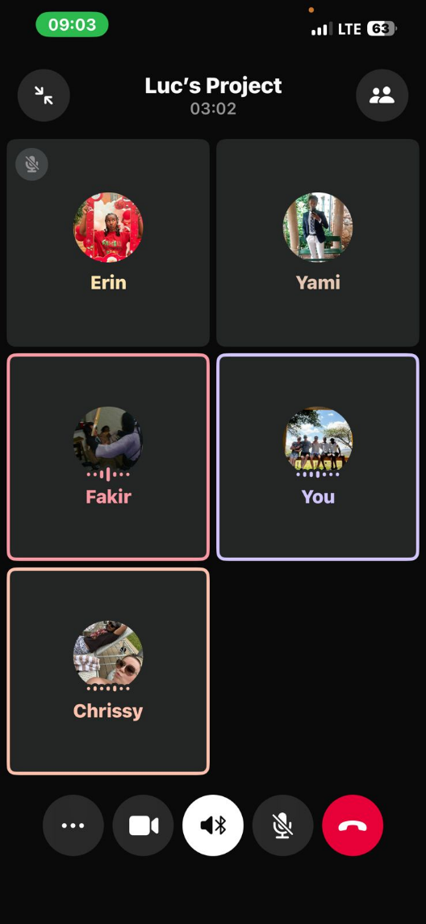

Sprint 2
Meeting 5: 13 April: 16:20-16:26
Full database integration by end of the week. Add document information such as user stories.
Stitch can help with the display for the template cards.
Fakir will have light-sail up by Wednesday
Everyone will need to work on a lot on the front end such as buttons working and reporting. Busy week, need to get all that’s needed by sprint meeting 2 done in time.
Use flex boxes, we want scrolling.
JSON processing will be the bulk.
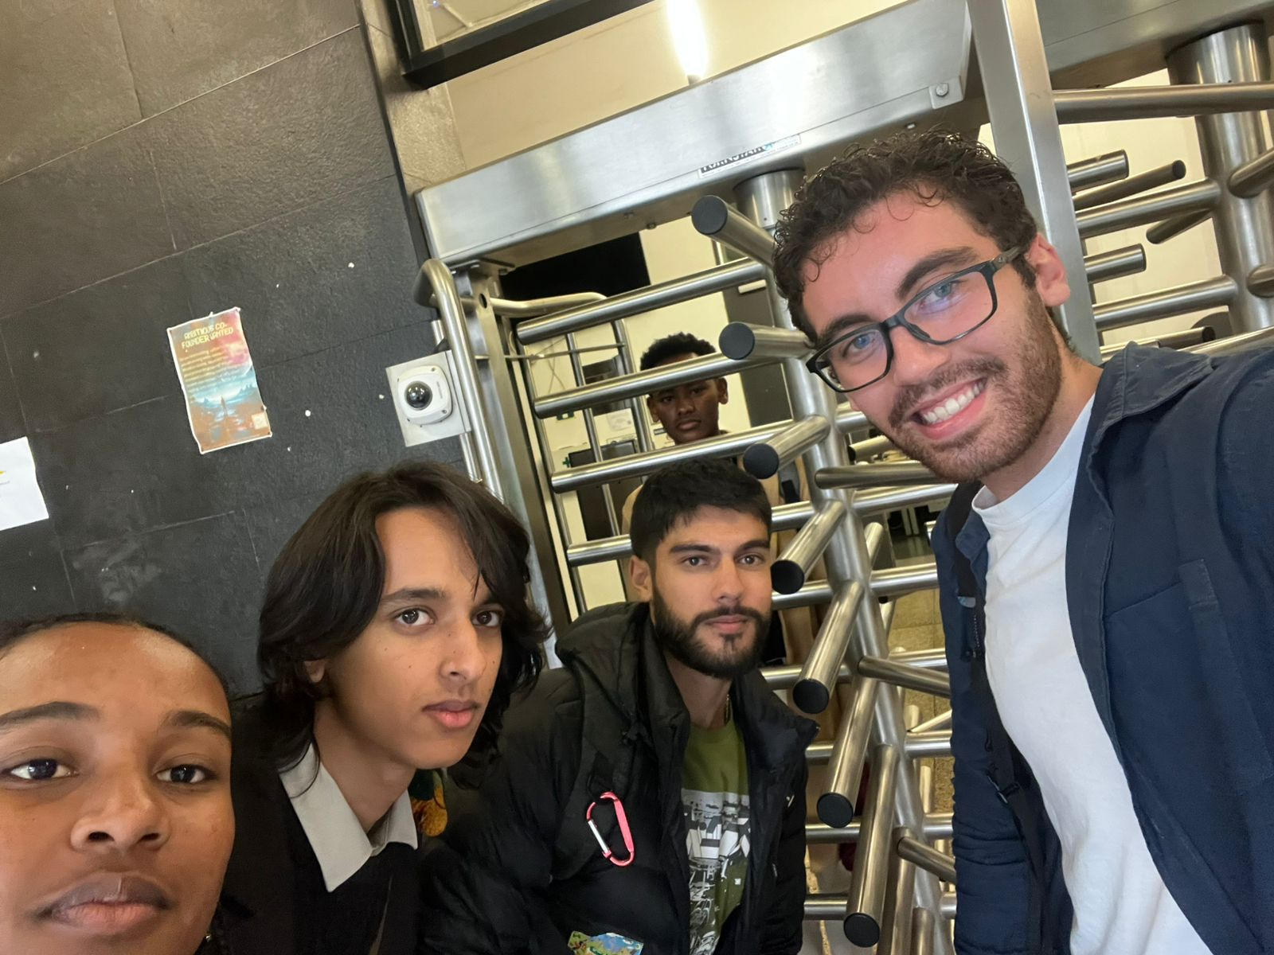

Scrum Meeting 6: 14 April 18:30-18:41
Luc did admin validation. Also did report page work for admins to assign it. Workers must be able to add pictures. Add delete reports for admins.
Chris will get reports fully done so residents can make reports. As well as maps for reports.
Yami will work with Chris on the resident page.
Fakir will get new database done.
Have a way for residents to say they have the same problem and have it so they can upvote a report.
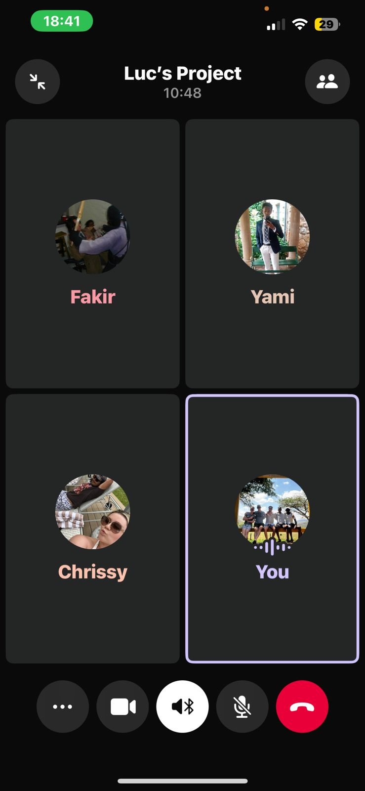
Scrum Meeting 7: 15 April 22:26-22:36
Luc must coordinate with Erin on building the rest of the municipal functionality
Chris and yami continuing work on reports
Fakir is continuing on resident home page functionality
documentation and user stories and UATs finished by erin
contact fakir for any lightsail db issues
running using npx instead of clicking run in a folder
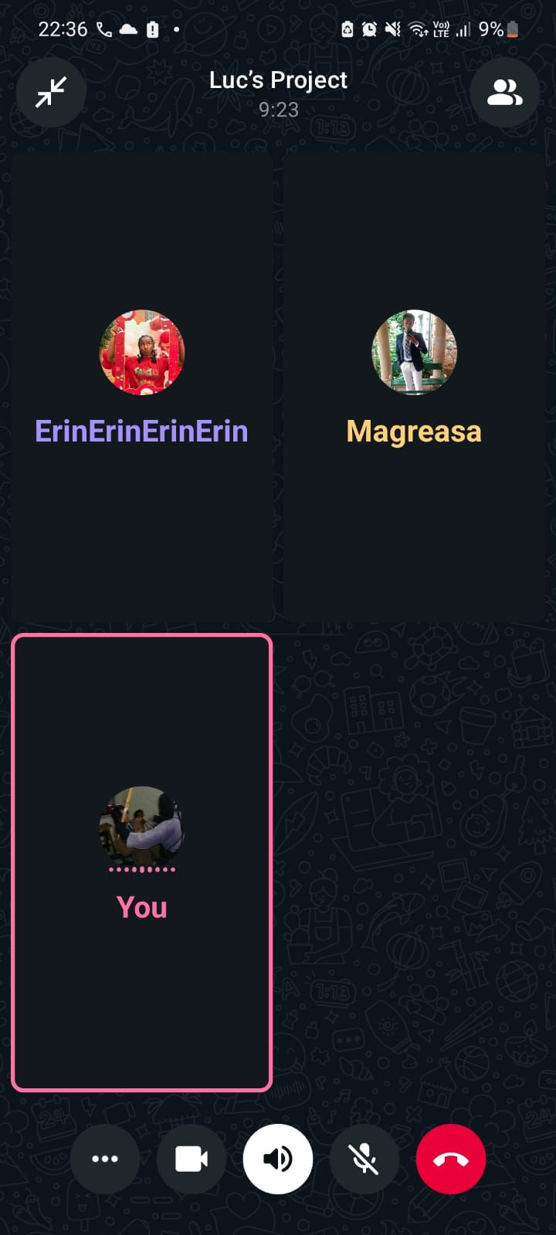

Scrum Meeting 8: 16 April 21:33-21:44
Chris is almost done with reports and the maps.
Yami is done with image capture, fixed drop down for wards and all that.
Fakir will push to main soon. Resident page functions for this sprint is basically done.
Luc is almost done with the admin page, will get workers page completely done soon.
Erin is going to work with notifications for residents. As well as image attachments for workers.
Chris will help Fakir with map backend code.
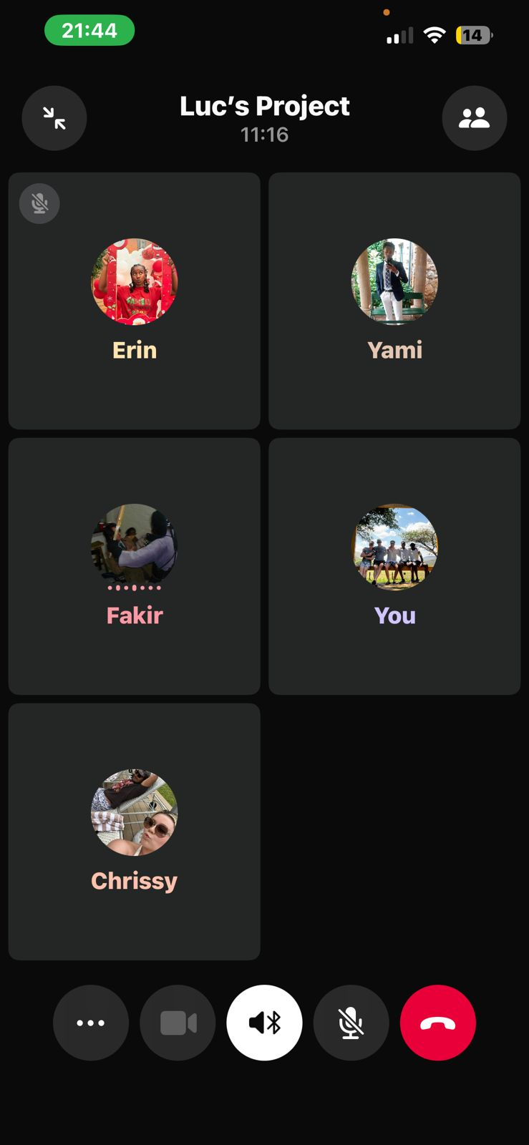
Sprint meeting 9: 19 April 19:01-19:09

Chris will finish up reports page and push to main by tonight, so will Yami.
Luc is done all his stuff. Will add a couple more things. Luc will add some test cases to bring the overall code coverage up.
Fakir put up all documentation
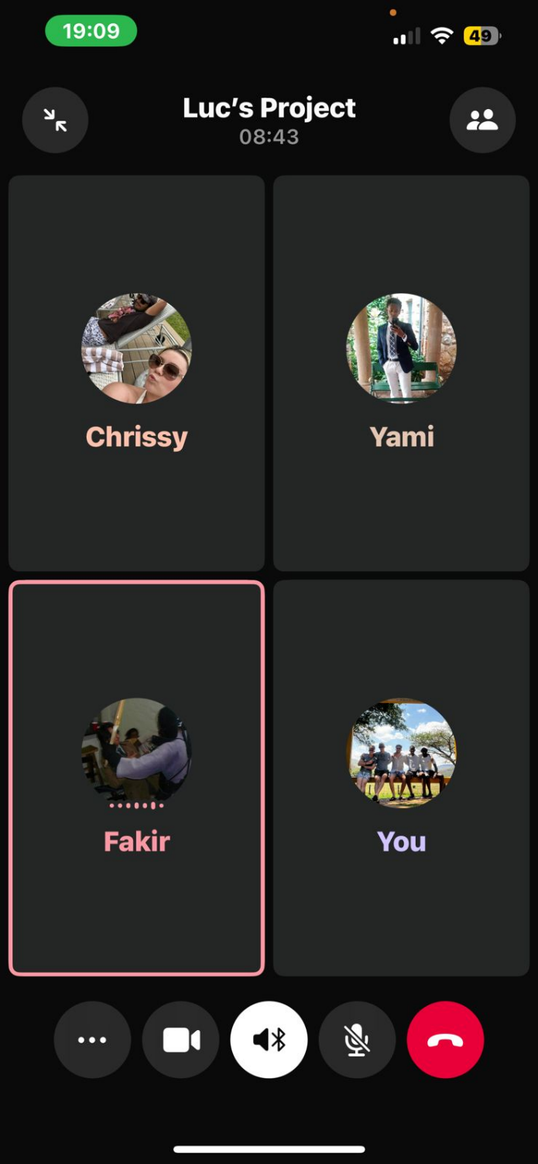

Sprint 3
Scrum Meeting 10: 20 April 17:30-17:34
Erin will work on notifications for everyone
Fakir will do analytics and have it export as pdf
Luc will add all his extra stuff for admin and worker.
Chris will touch up reports, and fix up images for all.
Yami will do public dashboard.
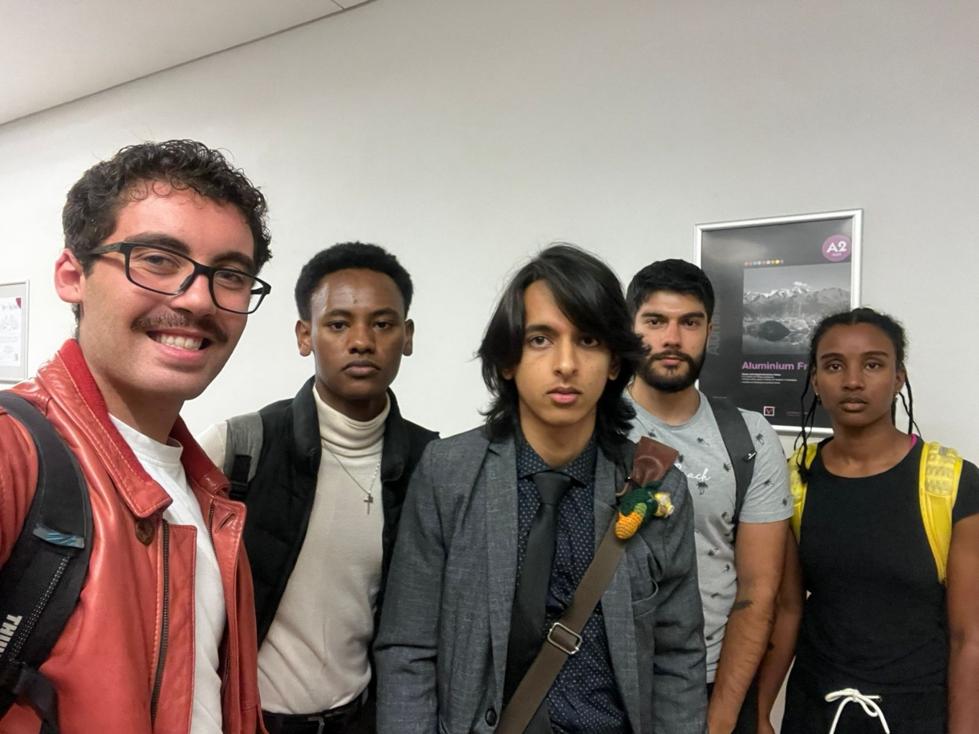

Scrum meeting 11: 21 April 18:01-18:13

Everyone must be involved in documentation.
Notifications- Erin will carry on with it, need it to appear at the top and make photo vibrate. Need push notifications and emails. Build the notifications as a class to make it easier for everyone else.
Chris will do resident feedback page for when reports are resolved. Residents should be able to give feedback as well as rate it as a 5 star.
Luc will do Municipal employees workers and admin notifications- for allocated tasks. Need push notifications and emails. (Email is second).
Yami will do public dashboard. Can’t make reports on there, it must load a blank page, doesn’t look for them in the database.
Notifications need management, need to be able to stop the notification.
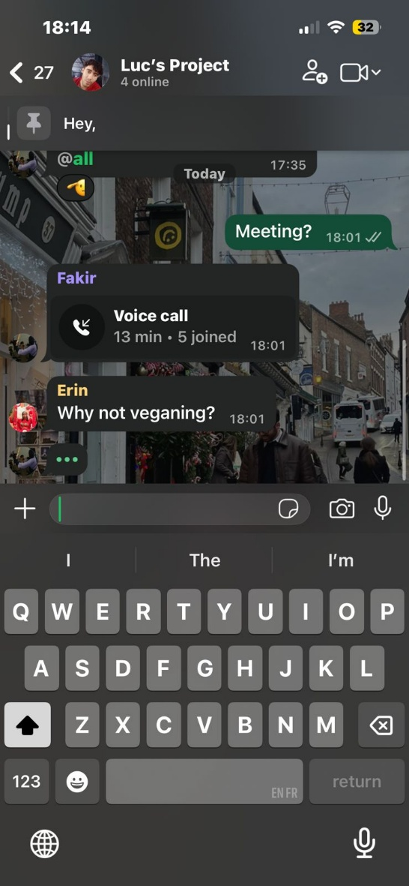
Scrum meeting 12: 23 April 11:47-11:56

Chris will get all his rating info done.
Luc and Erin work together on notifications done, need push and email.
Yami is still busy with dashboard. Ward maps. Near completion
Fakir is doing the map stuff, almost done.
Need map functionality on every page.
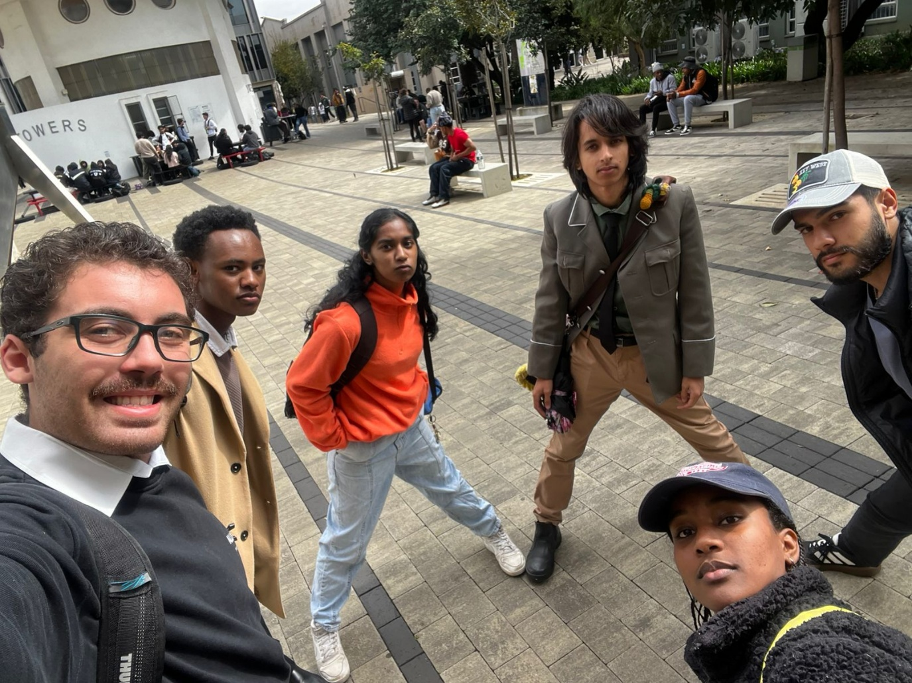

Scrum meeting 13: 24 April 20:02- 20:12

Fakir explained how database is working, what has changed is that there are more. municipal plaitys. ID of Johannesburg has changed to Cape Town ID.
Chris has a new page to see reports made by users. Working on a 5 star rating and image implementation. Hook up images to the reports.
Erin is done with resident notifications. Has settings to mute all.
Luc will make a real email. Has notifications done for workers and admin. Just needs to test email pausing.
Fakir has a report and map model to make things cleaner.
Need dynamic report classification next. No more drop downs, should read your location and find the ward and area you’re in.
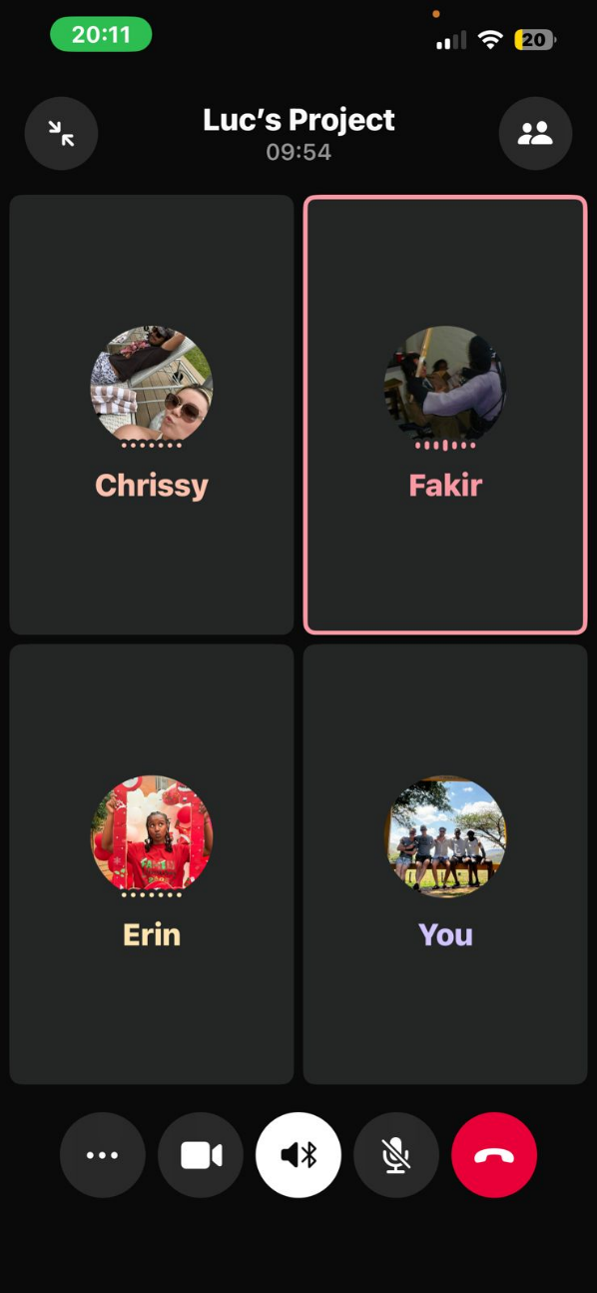
Sprint meeting 14 30 April: 11:55-12:07

Chris is adding user feedback so it’s only done once. Put on the report modal.
Luc will fix profile edit for emails, and work on documentation.
Yami working on documentation,
Erin working on functionality for notifications for residents. Image implementation for workers polish.
Fakir has fixed lots of bugs and problems with different things.
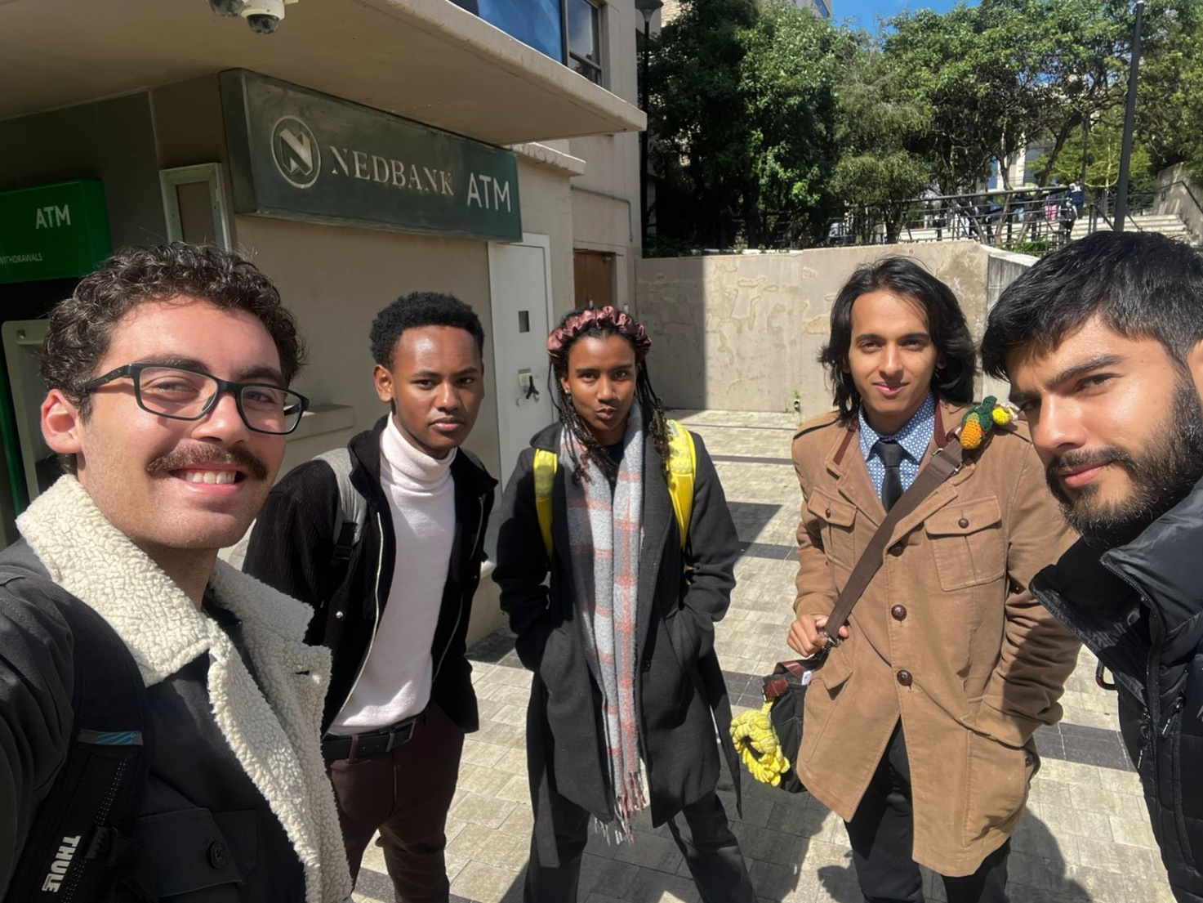

Sprint 4:
Sprint meeting 15: 11 May 15:07-15:16
We need to fix jest cases- 80% coverage for next week. All need to do.
Chris and Erin work in front end coverage.
Yami will work on last 5% for backend.
Luc will make sure we have every possible requirement we need for sprint 4. As well as add profile pictures and editing.
Make public dashboard as your main thing.
Add edit profile for spinners.
Erin for other spinners.
Luc work on better admin editing.
Yami will shuffle routeing

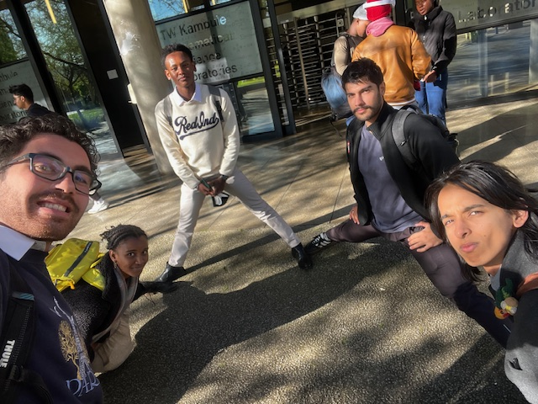

Scrum meeting 16: 12 May 2026 13:22- 13:29
Lots of little fixes for Luc, such as ugly modals must be cleaned up
Chris will fix up public dashboard as main.
Fakir will double checks for any things he thinks should be changed.
Yami will carry on with jest cases
Erin will carry on with spinners
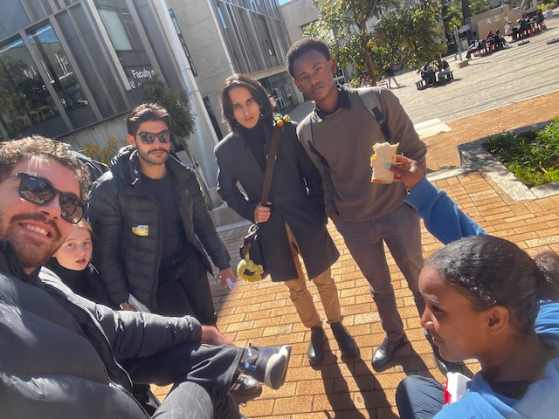

Scrum meeting 17: 13 May 08:31-08:40

Use toast for user popups to make it look better.
Luc is almost done with profile editing.
Add spinners to reports, admins, anything that needs loading. Disable button
Yami will need to add a submit edit to workers, where they update brief and pictures, add a resolve to dropdown to the percentages part, the 25,50,75%.
Erin will carry on with spinners.
Chris will carry on with test cases
Do not forget to run tests before you push.
Fakir will carry on looking at what doesn’t work and does, will fix some UML diagrams.

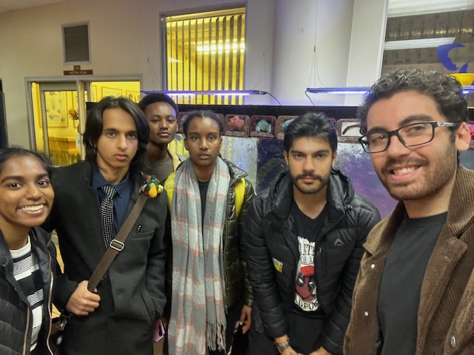

Scrum meeting 18: 15 May 11:55-12:02

Luc is done profile editing
Erin will carry on with spinners
Chris has added more tests cases, on track for 80% code coverage
Yami will carry on with worker edits
Fakir is almost done with all the UML diagrams
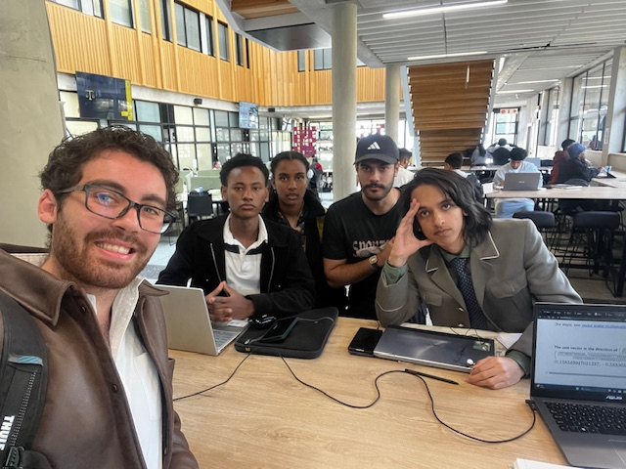

Scrum meeting 19: 16 May 18:02-18:16

Chris is almost done with tests cases for front end. Almost at 80%.
Erin has the loader going. Will make a minor adjustment to notifications.
Yami has done lots of test coverage for the backend folder. Almost done with changing what the workers can change. Such as description and priority. Add and remove images as well. Fixed the login page to be the guest dashboard first then move to login.
Luc will finish all the last little bit of admin polish and create UML diagrams for profile editing.
Fakir will fix pretty popups so we no longer use the ugly popups
